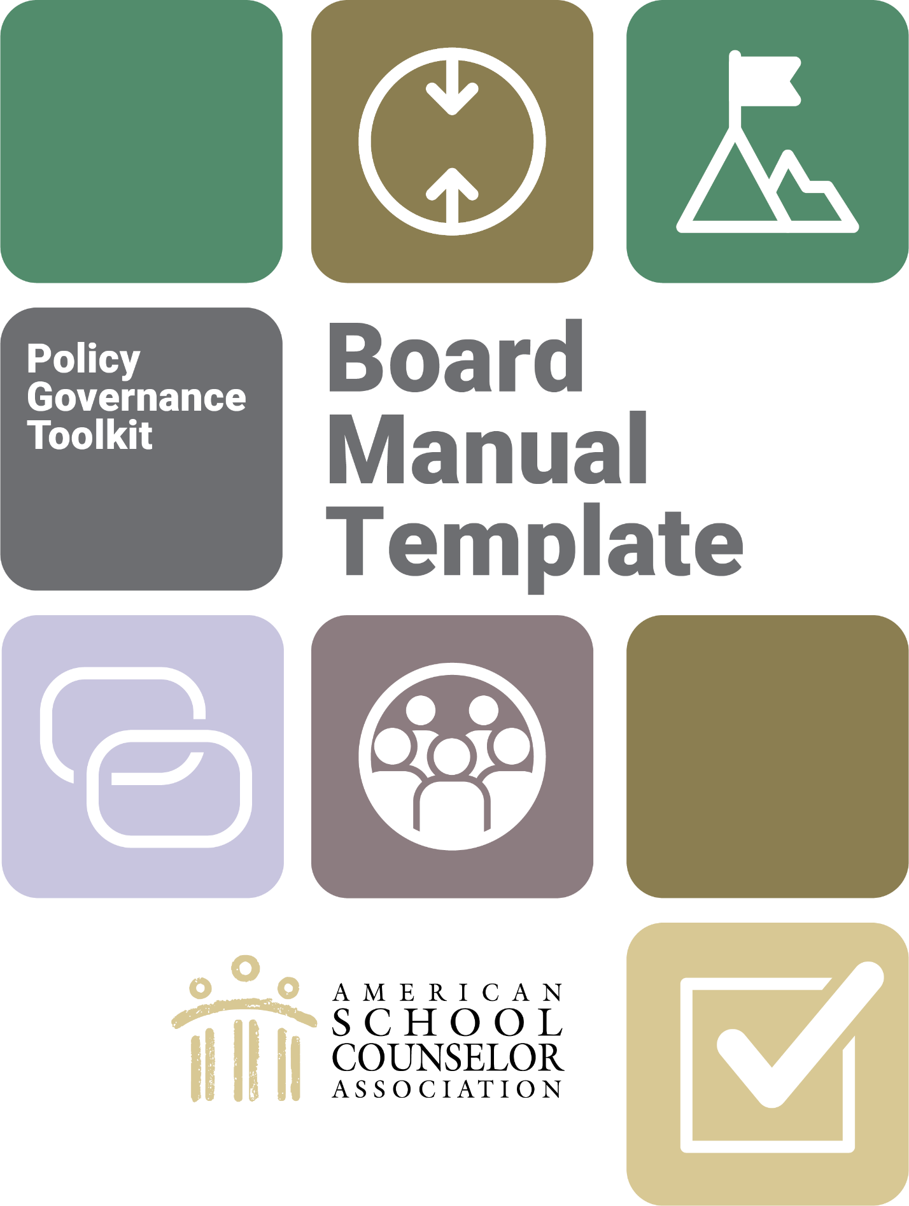

How to use this template

Here is a place to store all of your board’s organizing documents, including its Policy Governance-based policies in one convenient, easy-to-update manual and governance reference. This template serves as a starting point for associations to adapt to fit their needs. The headings are set up using MS Word styles and are hyperlinked to the table of contents so it’s easy to add, delete and update sections without having to renumber the table of contents. These hyperlinks will be maintained when you convert the file to a PDF for distribution. Simply customize each section to your association and remove the italicized directions.

## Finalizing your manual

Your final association board manual is designed to be kept in a binder with section dividers if you choose to print it. Alternatively, you may wish to use an electronic PDF version. Choose the format that will encourage the most use of the document by your members because they will be referring to this manual at every meeting if they are governing effectively.

## New board member orientation

Your finished manual is also the perfect orientation tool for new board members. With these uses in mind, the manual should be updated annually, so be sure to include that task on your board’s annual planning calendar.

**[Name of Association]**

**Board Governance Manual**

[INSERT DEVELOPMENT DATE]

[INSERT DATE BOARD APPROVED THE MANUAL]

[INSERT DATES DOCUMENT WAS UPDATED]

Table of Contents

Association Profile 4

History 4

Governing Policies and Procedures 5

Ends Policies 6

Executive Limitations Policies 7

Board-Management Delegation Policies 9

Governance Process Policies 10

Foundational & Legal Documents 13

Articles of Incorporation 13

Bylaws 13

IRS Letter of Determination 13

Contracts and Agreements 13

Board Conflict of Interest Statement 13

Board of Directors 14

Board Organization Chart 14

Board Member Contact List 14

Meeting Minutes 14

Board Calendar or Board’s Annual Plan 14

Financial 16

Signing Authorities 16

Board Education and Resources 17

Association Administration 18

Staff Contact List 18

Staff Job Descriptions 18

Association Profile

*Use this section to state the association’s vision and/or mission. Give a brief description of the benefits offered to members and the association structure.*

## 

## History

*Include a brief paragraph about when and where the association was established. Highlight important aspects of your work within the state or territory since your association’s inception.*

Governing Policies and Procedures

The following overview of Policy Governance is a useful reminder of how the model works and worth keeping in this manual.

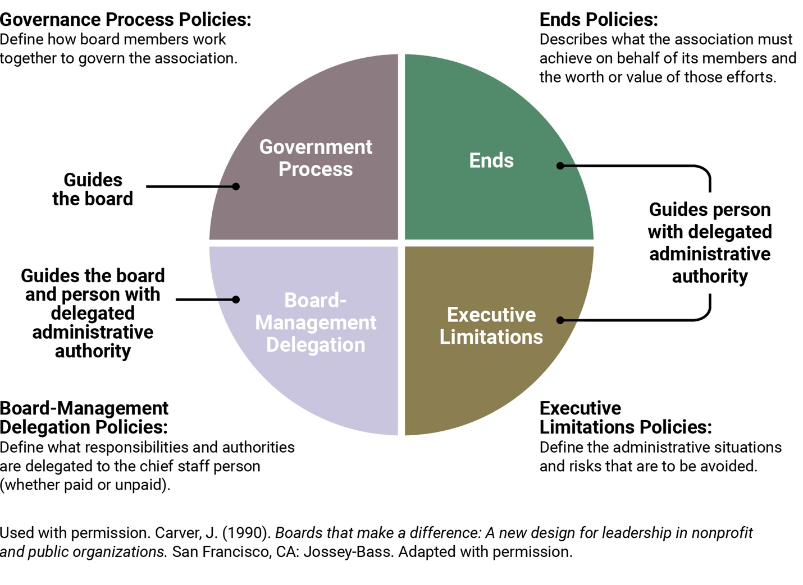

Your SCA’s board of directors has chosen to govern using an approach called Policy Governance©. Please see the Policy Governance Source Document on the Affiliate Exchange for an overview of the model. Simply put, using this approach means your board guides the decisions, actions, and behavior of the association through a framework of four types of policies. The board also follows ten principles that further define how to approach its job. The four types of policies (sometimes called “quadrants”) are: Ends, Executive Limitations, Board-Management Delegation, and Governance Process.

To keep this document clear and easy to understand, the assumption is that you will have a chief staff person (whether paid, volunteer, or attached to an Association Management Company) that we will refer to as the executive director or “ED”. If the concept an executive director causes you concern, please read the section on role clarity in the Policy Development Guide.

## Ends Policies

*Your completed Ends policies will go here.*

1.0 ENDS GLOBAL  
Overarching statement of why your SCA exists

1.1. Sub Ends go here

## Executive Limitations Policies

*Here is a starter set of Executive Limitations policies.*

1. **GLOBAL CONSTRAINT**   
   The ED shall not cause or allow any association practice, activity, decision, or circumstance that is unlawful, imprudent, or in violation of commonly accepted business and professional ethics and practices.
   1. **Emergency Executive Succession**  
      In order to protect the board from sudden loss of ED services, the ED shall not permit the board to be without fewer than two other volunteer leaders or contractors identified and prepared to take over interim operations of the association.
   2. **Protection of Assets**

The ED shall not cause or allow the association’s assets to be unprotected, inadequately maintained, or unnecessarily risked.

* 1. **Financial Planning, Budgeting and Management**

The ED shall not cause or allow planning for any fiscal year to deviate from the board’s Ends priorities, risk financial jeopardy, or a multiyear plan. Accordingly, the ED will not:

* + 1. Expend more funds than have been received in the fiscal year.
    2. Incur short-term debts in an amount greater than can be repaid within 60 days.
    3. Use any long-term reserves.
    4. Allow contract agreements and payroll debts to remain unpaid beyond what was promised in the agreement or policy.
    5. Allow tax payments or other government ordered payments or filings to be overdue or inaccurately filed.
    6. Make a single purchase or commitment of greater than $______. Splitting orders to avoid this limit is not acceptable.
  1. **Communication and Support to the Board**

The ED shall not cause or allow the board to be uninformed or unsupported in its work. Accordingly, the ED will not:

* + 1. Neglect to submit Ends and Executive Limitation policy monitoring reports to the board according to the schedule set in Board-Management Delegation.
    2. Present reports, or other information, to the board that are unnecessarily complex or lengthy.
    3. Let the board be unaware of any information affecting the image or credibility of the association (e.g., anticipated media coverage, threatened or pending lawsuits, major changes to the operation, major changes anticipated in the external environment).
    4. Allow the board to be without a workable communications system and online document accessibility for its official board, officer, and committee communications (e.g., Google, Slack, Asana, Trello).

**2.5. Treatment of Staff, Volunteers, and Contractors**

With respect to the treatment of paid and volunteer staff and contractors, the ED shall not cause or allow conditions that are unfair, disorganized, or exclusionary.

**2.6. Treatment of Members**

With respect to interactions with members or those applying to be members, the ED shall not cause or allow conditions, procedures, or decisions that are unfair, disorganized, unnecessarily intrusive, or exclusionary.

## Board-Management Delegation Policies

*Here is a starter set of Board-Management Delegation policies.*

1. BOARD-MANAGEMENT DELEGATION GLOBAL  
   The board delegates operational association authority to an Executive Director.
   1. **Board Direction to ED**

The board directs the ED through its policies on Ends and Executive Limitations.

* 1. **Monitoring and ED Performance**

Rigorous and systematic monitoring of the ED will be solely against the prescribed Ends to be achieved and the proscribed Executive Limitations to be avoided.

* 1. **Monitoring Method and Frequency**

The board will usually receive internal reports generated by the ED (this is “Internal” monitoring), except in the case of policy 2.4 Communication and Support to the Board. For this policy, the board is in the best position to determine if the ED is compliant or not (this is monitoring by “Direct Inspection”).

The board could also invite an external third party or independent report (such as a CPA compilation, review, or audit) to determine compliance. Any expense for independent reports needs to be considered prior to the ED’s annual planning and budgeting and reflected annually in 4.1.2 Cost of Good Governance and must be carefully and thoughtfully exercised. All policies that direct the ED will be monitored, ordinarily, on the following routine schedule:

|  |  |  |
| --- | --- | --- |
| Policy | Method | Frequency |
| Ends | Internal | Twice a year (e.g., January/June) |
| Global Executive Constraint | Internal | Annually |
| Emergency Succession | Internal | Every year during board transition, as part of onboarding (e.g., July) |
| Protection of Assets | Internal | Every year during board transition |
| Financial Planning,  Budgeting & Management | Internal | Quarterly (some budgeting provisions annually) |
| Communication and Support to the Board | Direct | Every year during board transition |
| Treatment of Staff, Volunteers, and Contractors | Internal | Annually |
| Treatment of Members | Internal | Annually |



## Governance Process Policies

*Here is a starter set of Governance Process policies.*

1. GOVERNANCE PROCESS GLOBAL   
   On behalf of its association members, the board shall ensure that [state or territory SCA] achieves appropriate results for appropriate persons for an appropriate cost, as specified in its Ends policies, and avoids unacceptable actions and situations, as prohibited in its Executive Limitations policies.
   1. **Governing Commitments**

The board will govern lawfully, observing the ten principles of Policy Governance (See Policy Governance Source Document in ASCA reference area) and following group responsibilities, fulfill commitments, and guidelines as defined in their current cost of governance policy.

* 1. **Board’s Job Products**

The job of the board is to a) be accountable to association members by listening to their expectations of the association and reporting on the association’s results, b) craft policies to guide association decisions, and c) monitor that the association has fulfilled the expectations laid out in policy.

* 1. **Group Responsibilities**

The board develops policies that guide associational decisions and sets the expectation for an open, honest, and ethical associational culture. Although individual board members may have expertise and knowledge important to the work of the board, the board will develop a sense of group responsibility rather than relying on the chairperson to ensure decisions are made through good group process.

* 1. **Code** of Conduct

The board commits itself to ethical, businesslike, and lawful conduct, including adequate individual study and preparation prior to meetings, proper use of authority, and appropriate decorum when acting as board members.

* 1. Conflict of Interest

Board members must avoid conflicts of interest with respect to their fiduciary responsibilities of care, loyalty, and obedience. There will be no self-dealing or business by a member. Members will annually disclose their involvement with other associations or with vendors and any associations that might be reasonably seen as representing a conflict of interest. When a board is to decide on an issue about which a member has an unavoidable conflict of interest, that member shall recuse themselves from discussions and voting.  
Note: You may also want to have a conflict of interest form that board members sign annually.

* 1. Cost of Good Governance

Governing well requires resources. The board will plan thoughtfully and prudently for annual board training, onboarding, and any outside assistance. In fiscal year 20__, a total of $_____ will be reserved for these needs.

Note: Providing a budget amount in advance of the fiscal year helps the ED ensure board priorities in Ends are not jeopardized. Note this task in the board’s annual planning calendar and be sure to update this policy and record the change in your board’s meeting minutes.

* 1. Fulfillment of Commitments

The board will always be mindful that its role is to develop policies that guide operational decision-making and assess compliance. This role is separate and distinct from the role of the ED or those with delegated operational authority, who plan and complete the work.

Note: You may want to include any required meeting attendance, committee commitments, and participation in events. You may also include guidance on discipline if the board or members do not fulfill their role.

* 1. Agenda Planning

To accomplish its stated objectives, the board will follow an annual governing agenda that schedules continuing review, monitoring and refinement of policies, demonstrate its accountability to association members, monitoring of policies, and activities to improve board performance through education, enriched dialogue and deliberation.

* 1. Annual Board Evaluation

The board will rigorously and continually improve its capacity to govern effectively by using its Governance Process policies as its guide.

* 1. Officer roles

Depending on the board officer requirements in your state’s statutes governing nonprofit corporations, you may have 2-3 key officer descriptions here.

4.10.1 Chair. Sometimes called board president, the chair is the head of the board and of the organization. The chair partners with the organization's leadership to promote the association. The chair conducts board meetings and ensures that the board’s directives stated in policy are implemented and monitored.

The chair is empowered to create committees and appoint committee chairs as needed to assist the whole board with its work.

**4.10.2** Secretary/Treasurer. In Policy Governance, these roles are often combined if permitted by state statute. The board's secretary is a very important role. The secretary provides members with required meeting notices, prepares agendas and provides guidance on proper meeting procedures as adopted by the board. The secretary takes minutes at board meetings, or designates a person for the task, and reviews and distributes the approved minutes.

The secretary prepares and maintains board records, such as minutes, monitoring reports, and committee reports, and ensures the accuracy and security of the records. The secretary is prepared to assume the leadership role when the president and/or vice president are unavailable.

The role of treasurer takes on a different type of importance in PG. The treasurer serves as the financial officer. In some cases, this simply means that the treasurer reviews any checks the ED writes to themselves. The treasurer can, perhaps, help the board understand monitoring reports of its fiscal policies or make recommendations for those policies. The treasurer may also be asked to review the annual tax form and assure the ED has provided accurate material to the board.

* 1. Use of Board Committees

Board committees, when used, support the work of the board and reinforce the wholeness of the board's job and never to interfere with delegation of authority from the board to the ED. Accordingly,

*Note: List the ad hoc or standing committees, if any, your board wants to use to help get its governing work done. These could include things like a Member Linkage Planning committee but wouldn’t include something like a programming committee (because planning a conference isn’t governing work).*

Foundational & Legal Documents

## 

## Articles of Incorporation

*For ongoing reference, include a printed copy of the stamped articles of incorporation from the Secretary of State. You should also include a link to the document at the Secretary of State’s website.*

*Note: No matter what type of IRS determination you have (501c6 or 501c3), some states require you to register as a charity if you plan to hold fundraisers. If that is the case in your state, include a copy of your registration here.*

## 

## Bylaws

*In this section, include a copy of the most current revisions of the association’s bylaws which indicates a revision date assuming there are adjustments your board made after personalizing the new governing policies.*

## 

## IRS Letter of Determination

*Your official letter can be stored here.*

## 

## Contracts and Agreements

*Attach any contracts or agreements the board has with its AMC, ED, or other contractor directly reporting to the board. For easy reference, the board may also want to have access to lease agreements for office or storage space, memorandums of understanding or partnership agreements with other organizations.*

## 

## Board Conflict of Interest Statement

*Include a template conflict of interest form for annual use with board members as it relates to 4.5 Conflict of Interest policy.*

Board of Directors

## 

## Board Organization Chart

*This includes title, length of term and number of terms.*

## 

## Board Member Contact List

Mailing addresses, email, phone and mobile and indicate preferred method of communication.

## 

## Meeting Minutes

*Use this section to provide the online link to approved annual general meeting or board meeting minutes (e.g., Google docs).*

## Board Calendar or Board’s Annual Plan

*Create an annual calendar with a meeting-by-meeting list of governing activities (e.g., onboarding, audit, committee selection, board officer elections) that are typically carried out each year. Here is a list of activities to get you started:*

* *Set or revise Policy monitoring schedule. (See Board-ED Delegation* Monitoring Method and Frequency*)*
* *Prepare for and complete new board member onboarding activities.*
* *Plan association member engagement activities (https://www.wildapricot.com/blog/member-engagement). Plot those activities on the annual planning calendar.*
* *Decide how the board will report on annual association results to association members. (see 4.2* Board’s Job Products*). Some states, such as California, require the board to publish an annual report.*
* *Board members sign annual Conflict of Interest statement. (see 4.5 Conflict of Interest)*
* *Decide how much money the board will need for its own work (example: costs related to association members listening sessions, going to training) and share that information with the ED before the budget is set. (see 4.6 Cost of Good Governance)*
* *Decide when the board will assess its own annual performance. (see 4.9* Annual Board Evaluation)
* Review the association’s bylaws and include other relevant activities such as selection of officers or appointment of volunteer administrative responsibilities. (See initial paragraphs in Governing Policies and Procedures section of this manual)
* Review and acceptance of annual 990 or other IRS reporting form. Although the Internal Revenue Code does not require the board to approve the forms, there is a requirement for the board to know what’s in the reports.
* Recruitment/nominations for board and board officers.

# Financial

## 

## Signing Authorities

*This section should list who has signing authority for the association at which institutions.*

# Board Education and Resources

Here are some examples of board education and resources you may choose to include:

* Meeting Management – (Affiliate Exchange links to items, such as Meeting Minutes: Best Practices)
* Communication – (Affiliate Exchange links to items, such as Managing Conflict)
* Board Member Orientation and Succession Planning – (Affiliate Exchange links to items, such as Onboarding Tutorial video)

# Association Administration

## 

## Staff Contact List

*This list includes staff and volunteer contact information, including preferred method of communication.*

## 

## Staff Job Descriptions

*Job descriptions should be available for each position within the association, both paid and volunteer. This answers the “who-does-what” for each SCA and is helpful for both board members and association members.*