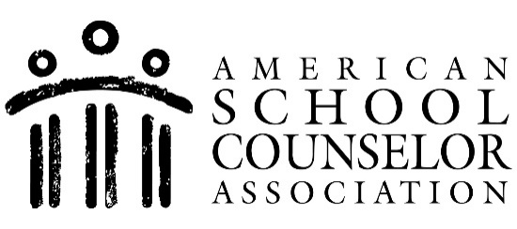

Media Contact
Kathleen Rakestraw
American School Counselor Association
703-683-2722
krakestraw@schoolcounselor.org

ASCA Awards RAMP Designation to [School Name]

For immediate release – DATE
ALEXANDRIA, VA. – The American School Counselor Association (ASCA) is pleased to announce [School Name] in [City, State] as a Recognized ASCA Model Program (RAMP).

The RAMP designation recognizes schools that are committed to delivering an exemplary school counseling program. Honorees are awarded for aligning their program with the criteria in the ASCA National Model, a framework for a data-informed school counseling program. Since the program’s inception, more than 1,000 schools earned the RAMP designation. Research findings indicate fully implemented school counseling programs are associated with a range of positive student educational and behavioral outcomes.

[Insert quote from school principal, district superintendent, etc. about the award.]

“This year’s RAMP honorees have shown their commitment to students and the school counseling profession,” said Jill Cook, ASCA executive director. “These schools used data to drive their program development and implementation so all students can achieve success. The RAMP designation distinguishes these schools and encourages school counselors nationwide to strive for excellence.”

[School Name] will be honored at a recognition ceremony at ASCA’s annual conference in Kansas City, Mo., on July 15, 2024.

RAMP applications are reviewed once a year. The next submission deadline is Oct. 15, 2024. For more information on the program, visit www.schoolcounselor.org/ramp.

###

About the American School Counselor Association

The American School Counselor Association (ASCA) is a nonprofit, 501(c)(3) professional organization based in Alexandria, Va. ASCA promotes student success by expanding the image and influence of school counseling through leadership, advocacy, collaboration and systemic change. ASCA helps school counselors guide their students toward academic achievement, career planning and social/emotional development to help today’s students become tomorrow’s productive, contributing members of society. Founded in 1952, ASCA has a network of 50 state and territory associations and a membership of approximately 43,000 school counseling professionals. For additional information on ASCA, visit www.schoolcounselor.org.

