

How to Use This Template

Here is a place to store all of your board’s organizing documents, including its Policy Governance-based policies, in one convenient, easy-to-update manual. This template serves as a starting point for associations to adapt to fit their needs. The headings are set up using MS Word styles and are hyperlinked to the table of contents so it’s easy to add, delete and update sections without having to re-number the table of contents. These hyperlinks will be maintained when you convert the file to a PDF for distribution. Simply customize each section to your association and remove the italicized directions.

## Finalizing your manual

Your final association board manual is designed to be kept in a binder with section dividers if you choose to print it. Alternatively, you may wish to use an electronic PDF version or use the categories to set up an electronic filing system of all your governing materials. Choose the format that will encourage the most use of the document by your members because they will be referring to this manual at every meeting if they are governing effectively.

## New board member orientation

Your finished manual is also the perfect orientation tool for new board members. With these uses in mind, the manual should be updated annually, so be sure to include that task on your board’s annual planning calendar.

**[Name of Association]**

Board Governance Manual

[INSERT DEVELOPMENT DATE]

[INSERT DATE BOARD APPROVED THE MANUAL]

[INSERT DATES DOCUMENT WAS UPDATED]

Table of Contents

How to Use This Template 1

Finalizing your manual 1

New board member orientation 1

History 4

Ends Policies 7

Executive Limitations Policies 9

Board-Management Delegation Policies 11

Governance Process Policies 13

Articles of Incorporation 17

Bylaws 17

IRS Letter of Determination 17

Contracts and Agreements 17

Board Conflict of Interest Statement 17

Board Organization Chart 18

Board Member Contact List 18

Meeting Minutes 18

Board Calendar or Board’s Annual Plan 18

Financial 20

Signing Authorities 20

Board Education and Resources 21

Association Administration 22

Staff Contact List 22

Staff Job Descriptions 22

Association Profile

*Use this section to state the association’s vision and/or mission. Give a brief description of the benefits offered to members and the association structure.*

## History

*Include a brief paragraph about when and where the association was established. Highlight important aspects of your work within the state or territory since your association’s inception.*

Governing Policies

The following overview of Policy Governance is a useful reminder of how the model works and worth keeping in this manual.

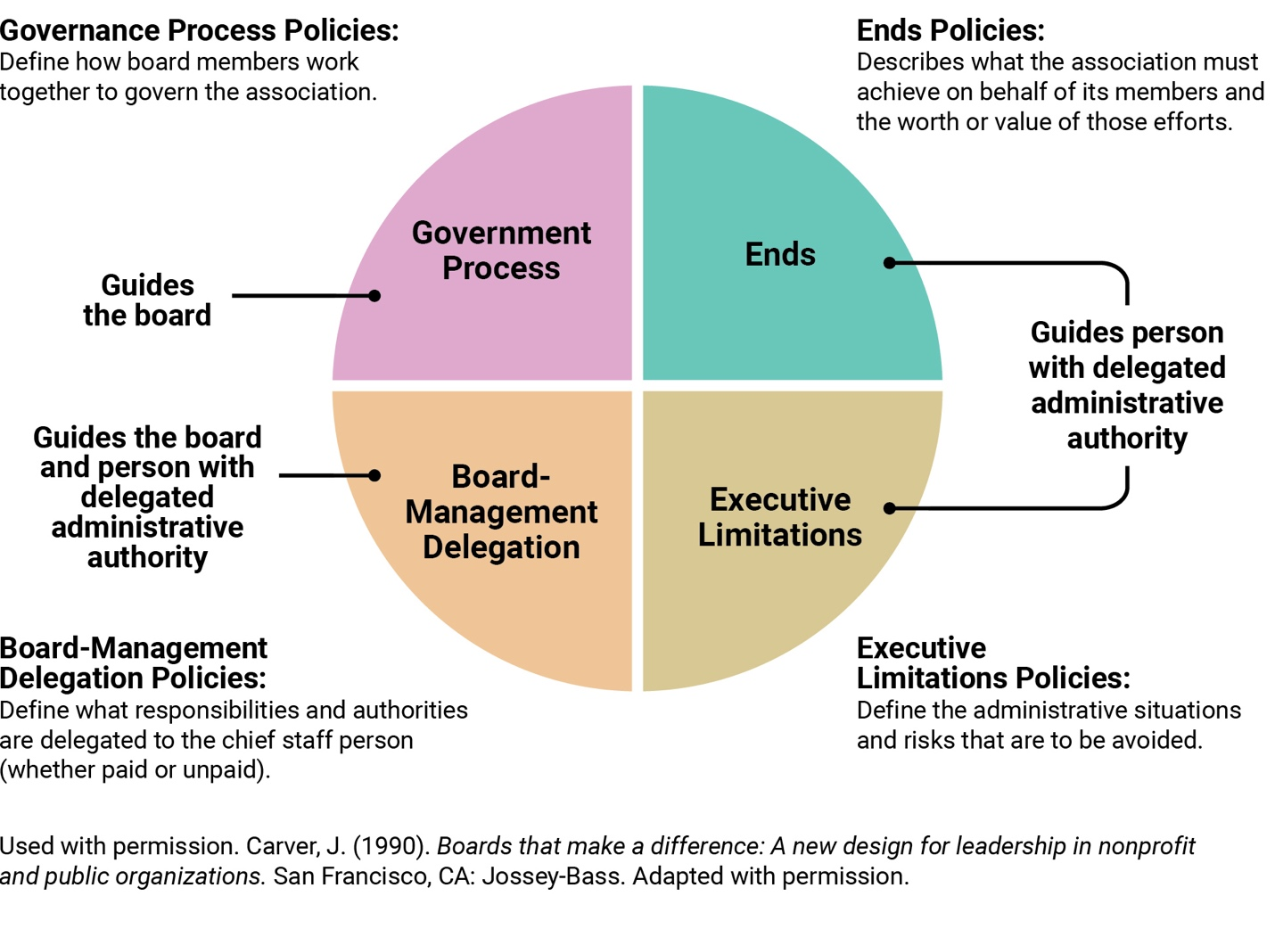

**Your SCA’s board of directors has chosen to govern using an approach called Policy Governance©.** For an overview of the model, please see the Policy Governance Source Document on the Affiliate Exchange.

Simply put, using this approach means the board guides the decisions, actions and behavior of the association through a framework of four types of policies: Ends, Executive Limitations, Board-Management Delegation and Governance Process. These policies, along with then key principles, define how the board approaches its work.

Throughout this manual, we often refer to a chief staff person – typically called an executive director – who is accountable to the board. However, we recognize that not all SCAs will have a single individual in this role. Some SCAs may share responsibilities among multiple individuals, rely entirely on volunteers or contract with an association management company.

To keep the manual simple and consistent, we use the term executive director when referring to the board’s primary point(s) of accountability. If your SCA’s structure looks different, we encourage you to read the "Role Clarity" section of the Policy Development Guide for ways to adapt the concepts to your situation.

## Ends Policies

*Your completed Ends policies – the outcomes you expect the organization to achieve for its members – will go here.*

**1.0 Ends**  
*Overarching statement of why your SCA exists, who it exists for and the worth or value of the resources.*

*1.1. Sub Ends go here*

*If your board needs some ideas to get started with their Ends, here are two samples:*

##### Sample A

1. *[SCA] exists for members to successfully fulfill their professional roles in environments characterized by informed and supportive key decision-makers, achieved with prudent use of association resources.*

* 1. *Members have local access to a full complement of skills and knowledge development opportunities needed for current and effective school counseling.*
     1. *Members have access to, and benefit from, local professional learning that strengthens their capacity to meet student needs.*
     2. *Growth in rates of participation across various key categories of membership is regularly demonstrated.*
     3. *Members are aware of trending changes in the state environment for school counseling and have access to various means for responding to those trends.*
  2. *Members benefit from public policy conditions favorable to their professional success.*
     1. *Members value the SCA’s role in creating a professional community.*
     2. *Members are knowledgeable of the methods available to communicate the value of the profession to local, state and national decision makers.*
     3. *Members are equipped to effectively communicate the value of school counseling to decision makers at local and state levels and are prepared to support national advocacy efforts led by ASCA.*

Sample B

***1.0*** *[State/Territory] School Counselor Association exists so school counselors are empowered to advance student success and well-being within supportive educational environments, using resources wisely and effectively.*

***1.1 School counselors are recognized as essential leaders in schools and communities.***

*1.1.1 School counselors are equipped to advocate for student needs and systemic change within their schools and districts.*

*1.1.2 School counselors influence education policy and practice at the local and state levels to promote student well-being and achievement.*

*1.1.3 School counselors maintain high ethical standards, pursue ongoing professional learning and strengthen connections to professional communities.*

***1.2 School counselors deliver equitable, data-informed school counseling programs.***

*1.2.1 School counselors implement comprehensive programs aligned with professional standards and responsive to student needs.*

*1.2.2 School counselors reduce barriers to student success and champion practices that support access, belonging and lifelong learning.*

*1.2.3 School counselors engage students, families and other educational partners in collaborative efforts to promote whole-child development.*



## Executive Limitations Policies

*Here is a starter set of Executive Limitations policies.*

1. **Global Constraint**  
   The executive director shall not cause or allow any association practice, activity, decision or circumstance that is unlawful, imprudent, or in violation of commonly accepted business and professional ethics and practices.
   1. **Emergency Executive Director Succession**  
      To protect the board from sudden loss of executive director services, the executive director shall not permit the board to be with fewer than two other volunteer leaders or contractor identified and prepared to take over interim operations of the association.

**2.2 Protection of Assets**

The executive director shall not cause or allow the association’s assets to be unprotected, inadequately maintained, or unnecessarily risked.

**2.3 Financial Planning and Budgeting**

The executive director shall not cause or allow financial planning or budgeting that:

* Deviates materially from achieving the board’s Ends,
* Risks financial jeopardy or
* Compromises long-term organizational sustainability.

**2.4 Ongoing Financial Conditions**

Throughout the course of the year, the executive director shall not allow undesirable financial conditions to develop. Accordingly, the executive director shall not:

2.4.1 **Fund Expenditure**. Expend more funds than have been received in the fiscal year unless otherwise approved by the board.

2.4.2 **Incurring Debt**. Incur short-term debt that cannot be repaid within 60 days.

2.4.3 **Use of Long-Term Reserves**. Use long-term reserves without board approval.

2.4.4 **Repaying Debt**. Allow contracts, agreements or payroll obligations to remain unpaid beyond the terms promised.

2.4.5 **Required Filings**. Allow tax payments or government-required filings to be overdue or inaccurately filed.

2.3.6 **Purchasing**. Make any single unbudgeted purchase or financial commitment greater than $______ without board approval. Splitting orders to avoid this limit is not permitted.

2.5 Communication and Support to the Board

The executive director shall not cause or allow the board to be uninformed or unsupported in its work. Accordingly, the executive director will not:

2.5.1 Timely Reports. Neglect to submit Ends and Executive Limitation policy-monitoring reports to the board according to the schedule set in Board-Management Delegation.

2.5.2 Clear Reports. Present reports, or other information, to the board that are unnecessarily complex or lengthy.

2.5.3 Reputation Threat Awareness. Let the board be unaware of any information affecting the image or credibility of the association (e.g., anticipated media coverage, threatened or pending lawsuits, major changes to the operation, major changes anticipated in the external environment).

2.5.4 Ease of Communication. Allow the board to be without a workable communications system and online document accessibility for its official board, officer and committee communications (e.g., Google, Slack, Asana, Trello).

2.6 Treatment of Staff, Volunteers and Contractors

With respect to the treatment of paid staff, volunteers and contractors, the executive director shall not cause or allow conditions that are unfair, disorganized or exclusionary.

2.7 Treatment of Members

With respect to interactions with members or those applying to be members, the executive director shall not cause or allow conditions, procedures or decisions that are unfair, disorganized, unnecessarily intrusive, or exclusionary.

## Board-Management Delegation Policies

*Here is a starter set of Board-Management Delegation policies.*

**3.0 Board-Management Delegation Global**  
The board delegates operational association authority (e.g. programs, marketing, member relations) to an executive director.

3.1 Board Direction to Executive Director

The board directs the executive director on the results to be achieved for members through its Ends policies and on situations to avoid through its Executive Limitations policies.

3.2 Monitoring executive director Performance

Rigorous and systematic monitoring of the executive director will be solely against the Ends to be achieved and the Executive Limitations to be avoided. Reports are assessed based on two questions: whether the operational interpretation of the board’s policy and the compliance measurement plan were reasonable and whether the data provided demonstrated compliance against the measurement plan.

3.3 Monitoring Method and Frequency

The board has three different methods to monitor organizational performance.

3.3.1 Internal Monitoring Reports. The board will most often rely on reports generated by the executive director to assess organizational performance against Ends and Executive Limitations.

3.3.2 Direct Inspection Monitoring. Compliance with some policies is determined subjectively by the board during its assessment discussion. This is the case with the Communication and Support to the board Executive Limitation policy. If desired, the board can also use direct inspection to determine compliance with other policies if they have the prerequisite skills. For example, reviewing organizational finances to see proof that the organization processed debt payments within the defined time period.

3.3.3 External “Third-Party” Monitoring. The board can invite an external entity to provide an independent report (e.g. a CPA compilation, review or audit) to determine policy compliance. This monitoring option must be carefully used so that inspection is directly against a specific policy. Any expense for independent reports should be considered.

**Sample Monitoring Schedule**

*The following is a sample monitoring schedule to illustrate how a board might plan its monitoring activities over the course of a year. Your SCA’s actual monitoring cadence and methods may look different depending on your organizational size, structure, capacity and priorities.*

*Boards are responsible for determining the timing and method for monitoring each policy and for adjusting the schedule to ensure meaningful oversight. Use this sample as a starting point, then tailor it to fit your specific context.*

|  |  |  |
| --- | --- | --- |
| Policy | Method | Frequency |
| Ends | Internal | Twice a year |
| Global Executive Constraint | Internal | Annually at end of cycle for monitoring all other Executive Limitations |
| Emergency Succession | Internal | Annually |
| Protection of Assets | Internal | Annually |
| Financial Planning &  Budgeting | Internal | Annually |
| Ongoing Financial Condition | Internal | Quarterly |
| Communication and Support to the Board | Direct | Annually |
| Treatment of Staff, Volunteers, and Contractors | Internal | Annually |
| Treatment of Members | Internal | Annually |

## Governance Process Policies

*Here is a starter set of Governance Process policies.*

**4.0 Governance Process Global**

On behalf of its association members, the board shall ensure that (state or territory SCA) achieves appropriate results for association members for an appropriate cost, as specified in its Ends policies, and avoids unacceptable actions and situations, as prohibited in its Executive Limitations policies.

4.1 Governing Commitments

The board will govern lawfully, observing the 10 principles of Policy Governance (see Policy Governance Source Document in ASCA reference area and save it in your association’s materials), and act in accordance with the association’s bylaws and these governing policies.

4.2 Board’s Job Products

The job of the board is to a) be accountable to association members by listening to their expectations of the association and reporting on the association’s results, b) crafting policies to guide association decisions and c) monitoring that the association has fulfilled the expectations laid out in policy.

4.3 Group Responsibility

The board continually works on its ability to operate in an open, honest and ethical team environment**.** Although individual board members may have expertise and knowledge important to the work of the board, the board will develop a sense of group responsibility. The board will not rely solely on the chair to ensure decisions are made through good group process by working together on their decision-making capabilities and process for addressing behaviors that violate the boards approach to governing.

4.4 Code **of Conduct**

The board commits itself to ethical, businesslike and lawful conduct, including adequate individual study and preparation prior to meetings, proper use of authority and appropriate decorum when acting as board members.

**4.5 Conflict of Interest**

Board members must avoid conflicts of interest with respect to their fiduciary responsibilities of care, loyalty and obedience. There will be no self-dealing or business by a member. Members will annually disclose their involvement with other associations or with vendors and any associations that might be reasonably seen as representing a conflict of interest. When a board is to decide on an issue about which a member has an unavoidable conflict of interest, that member shall recuse themselves from discussions and voting.

*(A conflict of interest form can be housed with your procedural materials. It does not belong within these policies.)*

**4.6** **Cost of Good Governance**

Governing well requires resources. The board will plan thoughtfully and prudently for annual board training, onboarding and any outside assistance. In fiscal year 20__, a total of $ _____ will be reserved for these needs.

*(Providing a budget amount in advance of the fiscal year helps the executive director ensure board priorities in Ends are not jeopardized, so note this task in the board’s annual planning calendar. Be sure to update this policy annually and record the change in your board’s meeting minutes.)*

**4.7** **Fulfillment of Commitments**

The board will always be mindful that its role is to develop policies that guide operational decision-making and assess compliance. This role is separate and distinct from the role of the executive director or those with delegated operational authority who plan and complete the work.

*Note: You may want to include any required meeting attendance, committee commitments and participation in events. You may also include guidance on discipline if the board or members do not fulfill their role.*

**4.8** **Agenda Planning**

To accomplish its stated objectives, the board will follow an annual governing agenda that schedules continuing review, monitoring and refinement of policies; demonstrate its accountability to association members; monitoring of policies; and activities to improve board performance through education, enriched dialogue and deliberation.

**4.9 Annual Board Evaluation**

The board will rigorously and continually improve its capacity to govern effectively using its Governance Process policies to define its expectations of itself.

**4.10 Officer roles**

*Depending on the board officer requirements in your state’s statutes governing nonprofit corporations, you may have two-three key officer descriptions here.*

**4.10.1 Chair.** Sometimes called board president, ensures the board’s directives to itself in the Governance Process and Board-Management Delegation policies are implemented and monitored. The chair is responsible for conducting the board’s meetings and planning meeting agendas in accordance with its annual plan. The chair also partners with the organization's executive director to promote the association when necessary.

The chair is empowered to create committees and appoint committee chairs to help the board accomplish its governing work but has no authority to appoint administrative committees. That authority is delegated to the executive director.

**4.10.2** **Secretary/Treasurer.** *In Policy Governance, these roles are often combined if permitted by state statute. The board’s secretary provides members with all required meeting notices, prepares agendas and provides guidance on proper meeting procedures as adopted by the board. The secretary takes minutes at board meetings, or designates a person for the task, and reviews and distributes the approved minutes.*

*The secretary prepares and maintains board records, such as minutes, monitoring reports and committee reports, and ensures the accuracy and security of the records. The secretary is prepared to assume the leadership role when the president and/or vice president are unavailable.*

*The role of treasurer takes on a different type of importance in Policy Governance. The treasurer serves as the financial officer. In some cases, this simply means that the treasurer reviews any checks the executive director writes to themselves. The treasurer can, perhaps, help the board understand monitoring reports of its fiscal policies or make recommendations for those policies. The treasurer may also be asked to review the annual tax form and assure the executive director has provided accurate material to the board.*

**4.11 Use of Board Committees**

Board committees, when used, support the work of the board and do not interfere with delegation of authority from the board to the executive director. Accordingly,

*Note: List the ad hoc or standing committees, if any, your board wants to use to help get its governing work done. These could include things like a Member Linkage Planning committee but wouldn’t include something like a programming committee (because planning a conference isn’t governing work).*

Foundational & Legal Documents

## Articles of Incorporation

*For ongoing reference, include a printed copy of the stamped articles of incorporation from the secretary of state. You should also include a link to the document at the secretary of state’s website.*

*Note: No matter what type of IRS determination you have (501c6 or 501c3), some states require you to register as a charity if you plan to hold fundraisers. If that is the case in your state, include a copy of your registration here.*

## Bylaws

*In this section, include a link to the most current revisions of the association’s bylaws, which indicates a revision date assuming there are adjustments your board made after personalizing the new governing policies.*

## IRS Letter of Determination

*Your official letter can be linked here.*

## Contracts and Agreements

*Attach links to any contracts or agreements the board has with its association management company, executive director or other contractors directly reporting to the board. For easy reference, the board may also want to have access to lease agreements for office or storage space, memorandums of understanding or partnership agreements with other organizations.*

## Board Conflict of Interest Statement

*Include a link to template conflict of interest form for annual use with board members as it relates to 4.5 Conflict of Interest policy.*

Board of Directors

## Board Organization Chart

*This includes title, length of term and number of terms.*

## Board Member Contact List

*Mailing addresses, email, phone and indicate preferred method of communication.*

## Meeting Minutes

*Use this section to provide the online link to approved annual general meeting or board meeting minutes (e.g., Google docs).*

## Board Calendar or Board’s Annual Plan

*Create an annual calendar with a meeting-by-meeting list of governing activities (e.g., onboarding, audit, committee selection, board officer elections) that are typically carried out each year. Here is a list of activities to get you started:*

* *Set or revise Policy monitoring schedule. (See Board-Executive Director Delegation* Monitoring Method and Frequency *policy)*
* *Prepare for and complete new board member onboarding activities.*
* *Plan association member engagement activities (Ideas can be found here: https://www.wildapricot.com/blog/member-engagement). Plot those activities on the annual planning calendar.*
* *Decide how the board will report on annual association results to association members. (see* Board’s Job Products *policy). Some states, such as California, require the board to publish an annual report.*
* *Board members sign annual Conflict of Interest statement. (see* Conflict of Interest *policy)*
* *Decide how much money the board will need for its own work (example: costs related to association members listening sessions, going to training) and share that information with the executive director before the budget is set. (see* Cost of Good Governance *policy)*
* *Decide when the board will assess its own annual performance. (see* Annual Board Evaluation *polic*y)
* *Review the association’s bylaws and include other relevant activities such as selection of officers or appointment of volunteer administrative responsibilities. (See initial paragraphs in Governing Policies section of this manual.)*
* *Review and acceptance of annual 990 or other IRS reporting form. Although the Internal Revenue Code does not require the board to approve the forms, there is a requirement for the board to know what’s in the reports.*
* *Recruitment/nominations for board and board officers.*

# Financial

## Signing Authorities

*This section should list who has signing authority for the association at which institutions.*

# Board Education and Resources

*Here are some examples of board education and resources you may choose to include:*

* *Meeting Management – (Affiliate Exchange links to items, such as Meeting Minutes: Best Practices)*
* *Communication – (Affiliate Exchange links to items, such as Managing Conflict)*
* *Board Member Orientation and Succession Planning – (Affiliate Exchange links to items, such as Onboarding Tutorial video)*

# Association Administration

## Staff Contact List

*This list includes staff and volunteer contact information, including preferred method of communication.*

## Staff Job Descriptions

*Job descriptions should be available for each position within the association, both paid and volunteer. This answers the “who-does-what” for each SCA and is helpful for both board members and association members.*