# ASCA No Limits @ Austin Texas/Virtual

# Sunday July 9th 2022– Wednesday July 12th, 2022

**EW 52332 ASCA 2022: No Limits – 3 Credit Hours**

Dear Conference Participant,

You can earn graduate credit from Lindenwood University through your participation in this conference. In order to earn credit, you will complete the following steps:

1. Visit <https://applylu.lindenwood.edu/applicationws.asp>, complete the Enrollment Form and pay with your credit card. (**Tuition fees are non-refundable)**
2. Fully participate in conference activities
3. Complete the assignments and email to [pceassignments@lindenwood.edu](mailto:pceassignments@lindenwood.edu) by **Monday,**  **August 8th, 2022.**

You can access an official grade report through the Lindenwood University student portal. Go to the <https://sportal.lindenwood.edu/estudent/login.asp>. Enter your username and password. The password will be provided from the university within 3-5 business days of registering. Go to My Grades on the left column under Administrative Services. Grade Type – select Final Grades. If it is not sufficient for your school district, a transcript will need to be requested through this link <https://secure.studentclearinghouse.org/tsorder/faces/TranscriptOrder?_afrLoop=124695261878666&_afrWindowMode=0&_adf.ctrl-state=f3bmh37kn_4#normalload>.

If you have questions regarding the process, your username/password or any other information, please feel free to contact me at [anthaniel@lindenwood.edu](mailto:anthaniel@lindenwood.edu) or by phone at 636-949-4612.

Sincerely,

 Azam Nathaniel  
Coordinator, Professional and Continuing Education  
[636.949.461](tel:+16369494618)2 (office) anathaniel@lindenwood.edu

|  |  |  |  |
| --- | --- | --- | --- |
| [Lindenwood University](https://www.lindenwood.edu/) |  |  | **REAL** EXPERIENCE. **REAL** SUCCESS. [lindenwood.edu](https://www.lindenwood.edu/) [Facebook](https://www.facebook.com/LindenwoodUniversity) [Twitter](https://twitter.com/@LindenwoodU) [LinkedIn](https://www.linkedin.com/edu/school?id=18701&trk=tyah&trkInfo=clickedVertical:school,clickedEntityId:18701,idx:2-1-9,tarId:1438358565061,tas:Linden) |

# 

# LINDENWOOD UNIVERSITY

# ASCA No Limit @ Austin/Virtual Conference

**EW 52332 3 Credit Hours**

**Location:** Austin/Virtual **Date(s):** Sun, July 12th, 2021 – Wed, July 19th, 2021

Lindenwood University offers individuals the opportunity to earn graduate credit through the participation in professional conferences and the completion of assignments listed on a Conference syllabus. To earn any credit, all assignments indicated on this syllabus must be completed.

Please attach all assignment as one file to ease the grading process.

**Directions for CC Assignment Submission:** Please email assignments to [pceassignments@lindenwood.edu](mailto:pceassignments@lindenwood.edu).

# Required Assignments

|  |  |
| --- | --- |
| **Assignments Titles** | **Expected Hours to Complete** |
| 1. Attendance Requirements | 20 |
| 2. Presentation | 10 |
| 3. Active reflection | 15 |

**Details of Assignments**

# Detailed Assignment Descriptions

## 1. **Attendance Requirements (20 hours):** Attend a minimum of 20 hours/sessions during the conference and record the name and length of time attended in a table like one below. Attend a minimum of 20 hours of sessions. List the sessions and time attended in the following format on a Word Doc as well s the total number of hours.

|  |  |
| --- | --- |
| **Session Name** | **Length of Time** |
|  |  |

**2. Presentation (10 hours):** Develop a presentation using PPT or similar program on selected topic from the conference. This may be an in depth look at one topic or more presented or an overview of the entire ASCA conference to share with your counseling colleagues who were unable to attend. Please identify the audience. Include a title slide, 15-20 slides and a source slide.

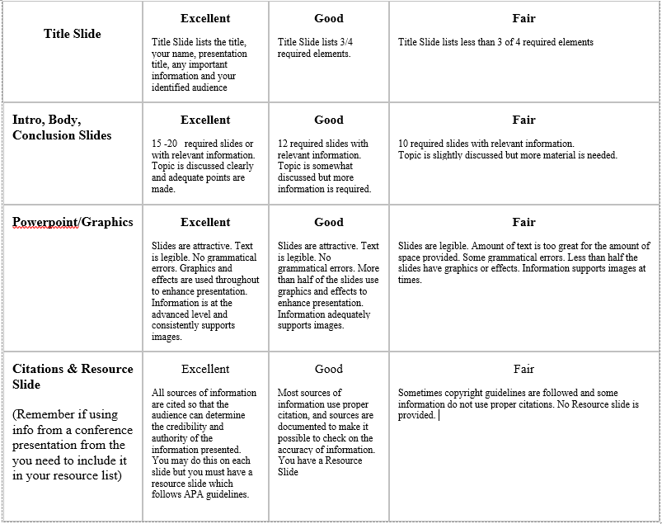

1. **Active Reflection (15 hours) Please** submit a double-spaced 3-5 page reflection.

The reflection should address what limits you in your role as a school counselor. Be sure to address personal and systemic challenges. How did this conference help you develop a “no limit” attitude or mind set? Please reference at least four sessions you attended which you will be able to apply this upcoming school year and how you will implement these ideas.

# The Grade Plan

**To earn a grade of “A”:** Fully participate in conference activities, and complete the written assignments including all of the detailed descriptions with clear explanations of your ideas. Minimal to no grammar or punctuation errors and completed by the designated deadline.

**To earn a grade of “B”:** Fully participate in conference activities and submit the minimum documentation required on the syllabus in a timely manner. Grammar and punctuation error, or failure to thoroughly complete assignments as described in the detailed descriptions will result in point deductions.

**To earn a grade of “C”:** Less than full participation in conference activities, and/or incomplete assignments that do not meet the standards of “A” or “B”.

Failure to meet the requirement of an “A”, “B”, or “C” will result in failure of the class.

**\*\*If you have any questions regarding the assignments or submitting the assignments, please email WLinton@lindenwood.edu**